The Tissue Box Project : These Character/Battles Will Blow You Away!
Directions: Research one of the following Civil War Leaders, Characters or Battles. Lay out and present your research in a visually appealing, well organized way, using each of the 4 sides wisely, based on their size and position on the tissue box.

Battles | Leaders/Characters
- 1st Bull Run  - Vicksburg  - Gettysburg  - Appomattox  - Cold Harbor  - Fredericksburg  - Antietam | - Abe Lincoln  - Robert E. Lee  - George McClellan  - Stonewall Jackson  - William Sherman  - Ulysses S. Grant  - Ambrose Burnside  - George Meade | - John Wilkes Booth  - Fredrick Douglass  - Clara Barton  - Harriet Tubman  - Jefferson Davis  *if you want to do a battle or person not on the list…see teacher!
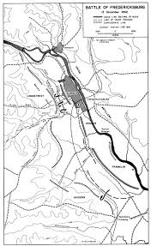
SIDE ONE: Leader or Character: Biography
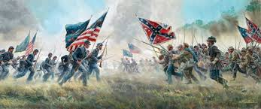
- Birth date and location
- Childhood info
- Why is this person important to this era?
- Marital status
SIDE ONE: Battle
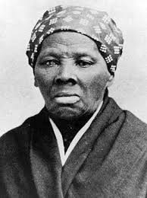
- Where was the Battle located?
- How many men on each side fought in Battle?
- What were the casualty results for each side?
- Why was the Battle significant?
SIDE TWO: Leader of Character- Resume
- Education
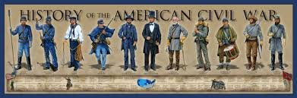
- Military service if any.
- Job experience, significance to time period
SIDE TWO: Battle –Main Generals for each side
- Who was in charge of the Northern and Southern Armies?
- What other general were present at the Battle?
- Who was the declared winner of the Battle?
SIDE THREE: Portrait, Map, Flag & Relevant Quote(s)
for example:
Portrait | Map (Battle)/Flag (Character) | quote
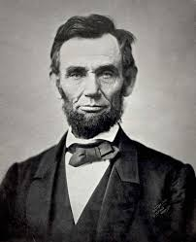 | 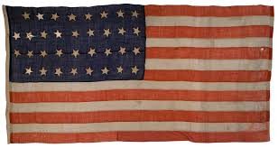 | “Plainly, the central idea of secession, is the essence of anarchy.” – March 4, 1861 – Lincoln’s First Inaugural Address

SIDE FOUR: Famous Images(drawings/photos/paintings/maps) of the Character or Battle.

Tissue Box Project due on:

